Name________________________________________Date__________Period__________

DNA Structure and Protein Synthesis
For each section, describe what the words mean and place the number in the correct spot on the diagram.

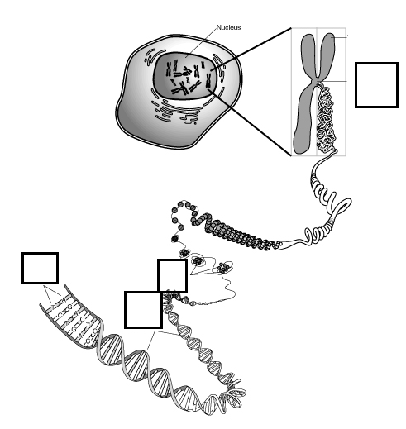
- Chromosome __________________________
___________________________________________
- Proteins (or histones) ____________________

___________________________________________

- Double helix _________________________
___________________________________________
- Base pairs (list the full names of the molecules that pair up in DNA)
____________________________________________
____________________________________________

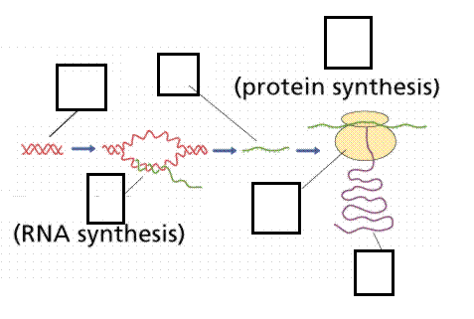
PROTEINS SYNTHESIS
- DNA (what is it and where is it?)_________________________
_____________________________
_____________________________
- Transcription ____________
____________________________
_____________________________
- Translation _____________
_____________________________
_____________________________
- mRNA ____________________________________________________________________________________
- Ribosome _________________________________________________________________________________
- Protein ___________________________________________________________________________________
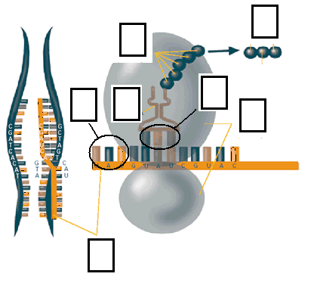
- mRNA
- Ribosome
- tRNA _______________
_________________________________
_________________________________
- Codon ______________
__________________________________
__________________________________
- Anti-codon ___________
__________________________________
__________________________________

- Amino acids ___________________________________________________________________________
- Polypeptide chain (or protein) _____________________________________________________________

