Name__________________________________________________Date________________Period______

Plate Tectonics and Ocean Currents
The following maps show how the continents have moved over time. Your task is to draw the warm and cold ocean currents during each time period. Go to Google.com and do an image-search for the following terms to help you.
“Permian ocean currents” “Jurassic ocean currents” “Present day ocean currents”
“Triassic ocean currents” “Cretaceous ocean currents”

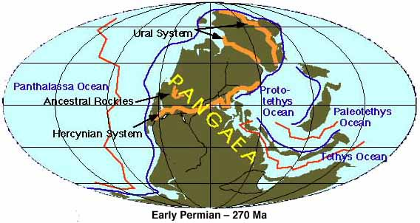

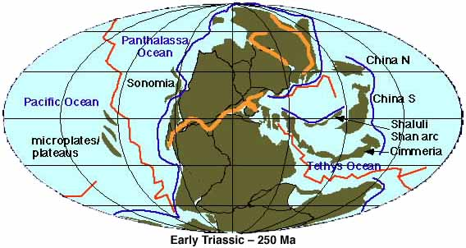
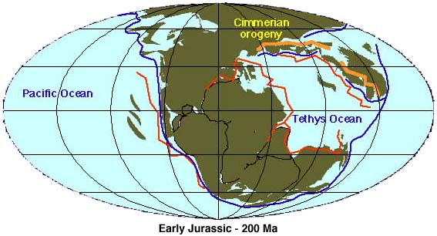

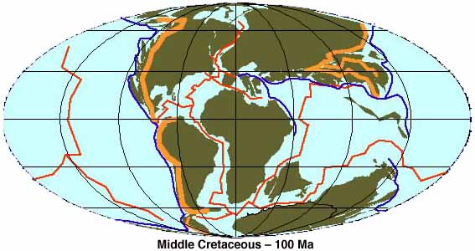

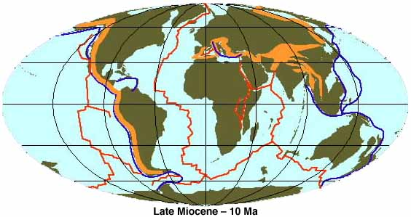

Present day

In the following table, write three statements under each column.
- One statement should explain what you see happening to the continents over time and how it affects ocean currents
- One statement should be about the patterns of the ocean currents and how it affects their temperatures
- One statement should be about the temperatures of currents that are next to the US and how it affects the climate of the region

What I See | What It Means

